GLOBAL AI OLYMPIAD COURSE • CHAPTER 3
AI at Work & AI for Innovation
Automate • Augment • Innovate
Concept Pages • Worksheets • Activities • Puzzles

Undergraduate • Year 3 | Work Smarter • Think Bigger
Name: ______________________________ Class: ______________ Roll No.: ______________

START HERE | Welcome, Innovator!

Chapter 3 shows how AI is changing the way we work and how it can power new ideas. You will learn to choose tasks to automate, redesign processes, measure results, and use design thinking to innovate responsibly.
By the end of this chapter you will be able to…
- Tell automating, augmenting and human-led work apart.
- Pick good tasks to automate with an impact–effort matrix.
- Describe AI uses in support, HR, finance, marketing, operations and IT.
- Map a process and redesign it with AI plus human review.
- Measure value with time saved, quality and ROI.
- Use design thinking and AI to build and pitch an idea responsibly.

CONCEPT – read & learn | WORKSHEET – practise | ACTIVITY – do & design
PUZZLE – have fun | QUIZ – test yourself | ANSWERS – check
Contents
3 | Concept 1 | AI at Work: Automate, Augment, Human-led
4 | Worksheet 1 | Sort the Tasks
5 | Concept 2 | Finding the Right Tasks to Automate
6 | Activity 1 | My Task Audit
7 | Concept 3 | AI Applications Across the Workplace
8 | Worksheet 2 | Match the Function
9 | Concept 4 | From Process Map to Automation
10 | Activity 2 | Redesign a Process
11 | Concept 5 | Measuring Value: Time, Quality, ROI
12 | Worksheet 3 | ROI Maths
13 | Concept 6 | AI as an Innovation Partner
14 | Activity 3 | Idea Sprint
15 | Concept 7 | Design Thinking with AI
16 | Worksheet 4 | Empathy to Prototype
17 | Concept 8 | AI for Innovation Around the World
18 | Activity 4 | Innovation Pitch Canvas
19 | Concept 9 | Responsible Innovation and the Future of Work
20 | Worksheet 5 | Fact or Fib?
21 | Puzzle | Work & Innovation Word Search
22 | Quiz | Olympiad Challenge Quiz
23 | Answers | Answer Key
Photographs in this book are AI-generated images created for teaching.

CONCEPT 1 | AI at Work: Automate, Augment, Human-led


AI changes tasks more than whole jobs. A job is a bundle of tasks. AI can take over some, assist with others, and leave the rest to people.
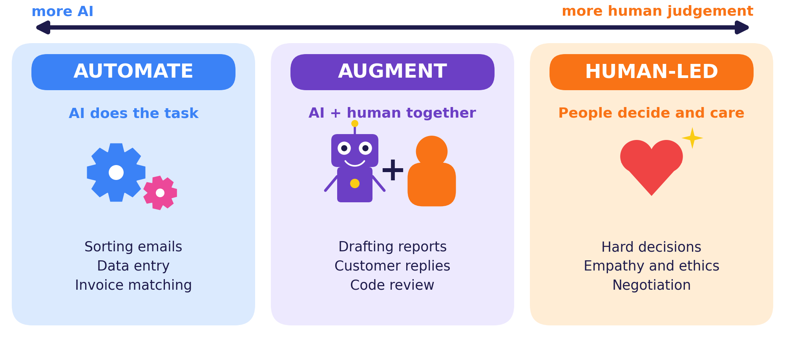
AUTOMATE | AUGMENT | HUMAN-LED
Repetitive, rule-based, digital, low risk if wrong. | Needs speed and ideas from AI plus checking by a person. | Needs empathy, ethics, trust or high-stakes judgement.

Remember
Automation takes over a task. Augmentation helps a person do more. The goal is better work, not just less work.

Think!
List three tasks in your daily study routine. Which could be automated, which augmented, and which must stay human-led?

Did you know?
Most jobs are bundles of tasks. When AI takes over some tasks, the job often changes shape instead of disappearing.

WORKSHEET 1 | Sort the Tasks
Name: ____________________ Class: __________ Date: __________ Score: ______
TASK A Tick the best home for each task.
# | Task | Automate | Augment | Human
1 | Renaming and filing 500 scanned invoices | ☐ | ☐ | ☐
2 | Writing the first draft of a weekly project report | ☐ | ☐ | ☐
3 | Telling an employee that their role is ending | ☐ | ☐ | ☐
4 | Sorting incoming support emails by topic | ☐ | ☐ | ☐
5 | Reviewing code with an AI assistant’s suggestions | ☐ | ☐ | ☐
6 | Negotiating a contract with a key client | ☐ | ☐ | ☐
7 | Copying totals from receipts into a spreadsheet | ☐ | ☐ | ☐
8 | Preparing a customer reply that a person checks before sending | ☐ | ☐ | ☐
9 | Deciding what a company’s ethics policy should say | ☐ | ☐ | ☐
10 | Scheduling meetings across time zones | ☐ | ☐ | ☐
TASK B Choose a task from your own study life that AI could augment. Explain how.
TASK C Sketch a human + AI team working on one task. Label who does what.

CONCEPT 2 | Finding the Right Tasks to Automate


Not every task deserves automation. A simple impact–effort matrix helps you choose where to begin.
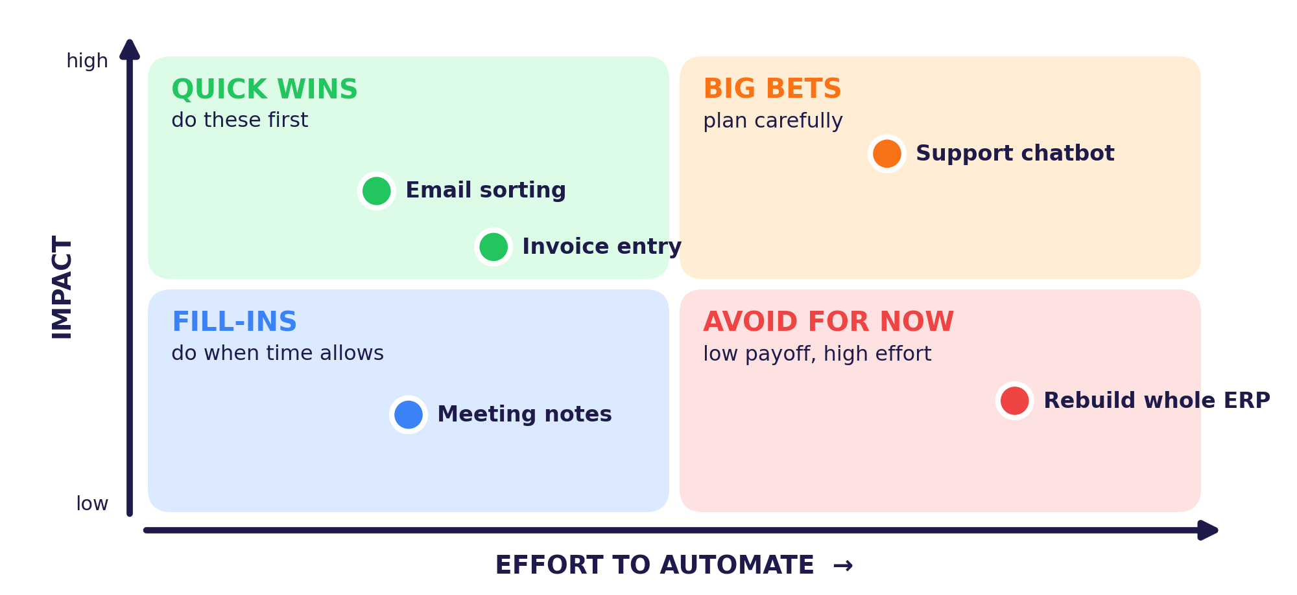
Good candidates | Poor candidates
Frequent and repetitive • Clear rules and digital data • Low risk if a mistake happens • Easy to measure | Rare or one-off • Ambiguous or full of exceptions • High stakes for people • Needs empathy or judgement

Start small
Pick a quick win, run a pilot with real users, learn from the results, then scale up. Big bets come after you have proof.

ACTIVITY 1 | My Task Audit
Name: ____________________ Class: __________ Date: __________ Score: ______
TASK A Score each task from 1 to 5. Rule: impact 4–5 = high, effort 4–5 = high. Write the quadrant.
Task | Freq. | Effort | Impact | Quadrant
Sorting incoming email | 5 | 2 | 4
Writing the monthly report | 2 | 3 | 3
24/7 customer-support chatbot | 5 | 4 | 5
Rebuilding the whole company system | 1 | 5 | 2
TASK B Place your two own tasks on the matrix. Write 1 and 2 in the right box.
HIGH IMPACT | QUICK WINS (low effort) | BIG BETS (high effort)
LOW IMPACT | FILL-INS (low effort) | AVOID FOR NOW (high effort)
TASK C Which task would you pilot first? Give two reasons.

CONCEPT 3 | AI Applications Across the Workplace


Almost every department now uses AI as a helper. The best uses pair a clear goal with good data and a person who can step in.
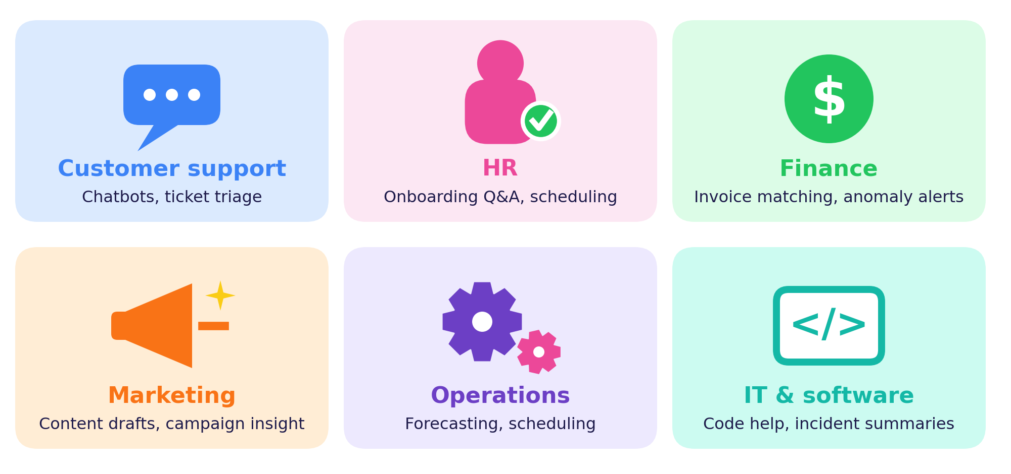
Function | AI helps with | Humans still
Customer support | Answering common questions, sorting tickets | Handle complex or upset cases
HR | Policy Q&A, scheduling, onboarding guides | Make hiring and people decisions
Finance | Matching invoices, flagging unusual payments | Investigate and approve
Marketing | Drafting content, summarising campaign data | Set strategy and brand voice
Operations | Forecasting demand, planning schedules | Make final plans
IT & software | Code suggestions, incident summaries | Fix, secure and release

Example
A support chatbot answers “Where is my order?” while a person handles refund disputes and upset customers.

WORKSHEET 2 | Match the Function
Name: ____________________ Class: __________ Date: __________ Score: ______
TASK A Match each department (1–6) to its best AI use (A–F). Write the letter.
Department | Letter | AI use
1 Customer support | ____ | A. Flags unusual card payments for review
2 HR | ____ | B. Drafts three versions of a product email
3 Finance | ____ | C. Answers common questions at any hour
4 Marketing | ____ | D. Forecasts next month’s stock needs
5 Operations | ____ | E. Answers new joiners’ questions about leave policy
6 IT & software | ____ | F. Summarises overnight server alerts
TASK B A chatbot receives: “My order is late and I am very upset.” Should it handle this alone? When should it hand over to a person?
TASK C A demand-forecasting model needs data. Tick appropriate or not appropriate.
Data source | Appropriate | Not OK
Past monthly sales records | ☐ | ☐
The holiday and festival calendar | ☐ | ☐
Employees’ private chat messages | ☐ | ☐
A competitor’s confidential files | ☐ | ☐

CONCEPT 4 | From Process Map to Automation


A process is a chain of steps that turns an input into a result. Mapping the steps shows where AI can save time and where people must stay involved.
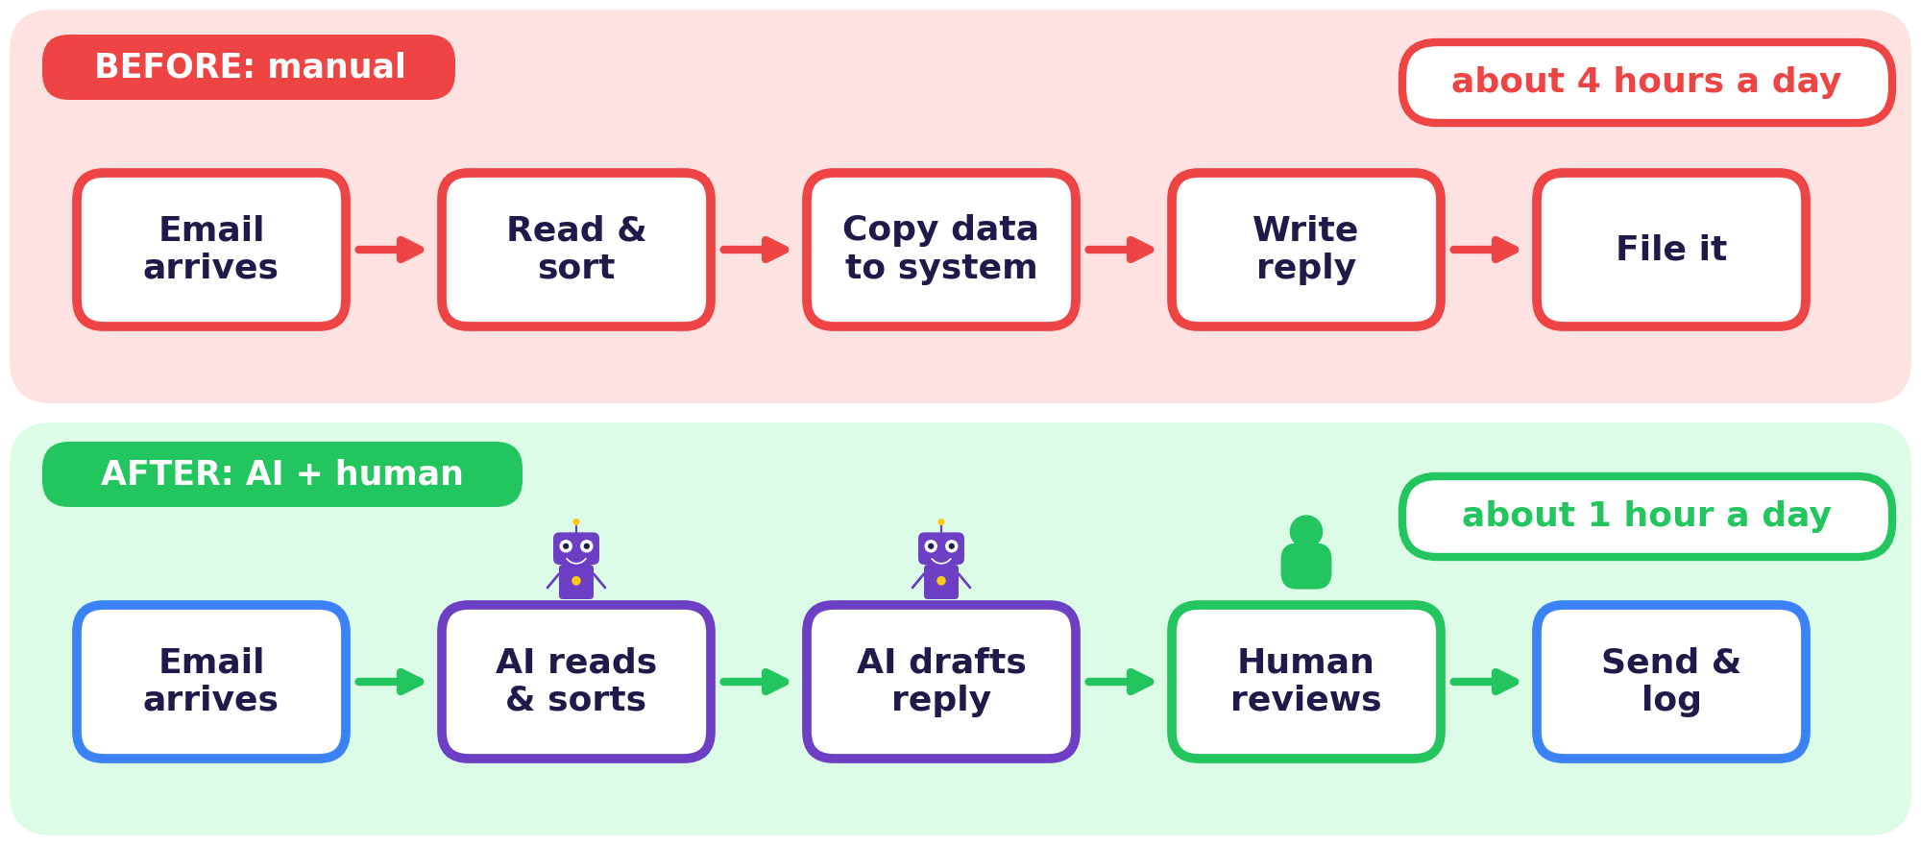
 | Step | Key question
1 | Map the current process | What happens now, and how long does each step take?
2 | Find the slow or repetitive steps | Which steps are routine and rule-based?
3 | Decide who does what | Human, AI, or both together?
4 | Build a small pilot | Can we test it safely with real work?
5 | Measure and improve | Did time, cost and quality get better?

Keep a human check
Wherever a mistake would be costly or unfair, keep a person in the loop to review the AI’s work before it goes out.

Data check
Is the data accurate, up to date and allowed to be used for this purpose?

ACTIVITY 2 | Redesign a Process
Name: ____________________ Class: __________ Date: __________ Score: ______
Process: “Handling a student’s leave request.”
TASK A Write the five steps of the CURRENT manual process, one per box.
Step 1 | Step 2 | Step 3 | Step 4 | Step 5
TASK B Redesign it. Tick who should do each step and say why.
Step | Human | AI | Both | Reason
Step 1 | ☐ | ☐ | ☐
Step 2 | ☐ | ☐ | ☐
Step 3 | ☐ | ☐ | ☐
Step 4 | ☐ | ☐ | ☐
Step 5 | ☐ | ☐ | ☐
TASK C Draw your improved flowchart. Mark where a person reviews.

CONCEPT 5 | Measuring Value: Time, Quality, ROI


An automation is only a success if the numbers improve. Compare results before and after, and always include the cost of the tool and the effort.
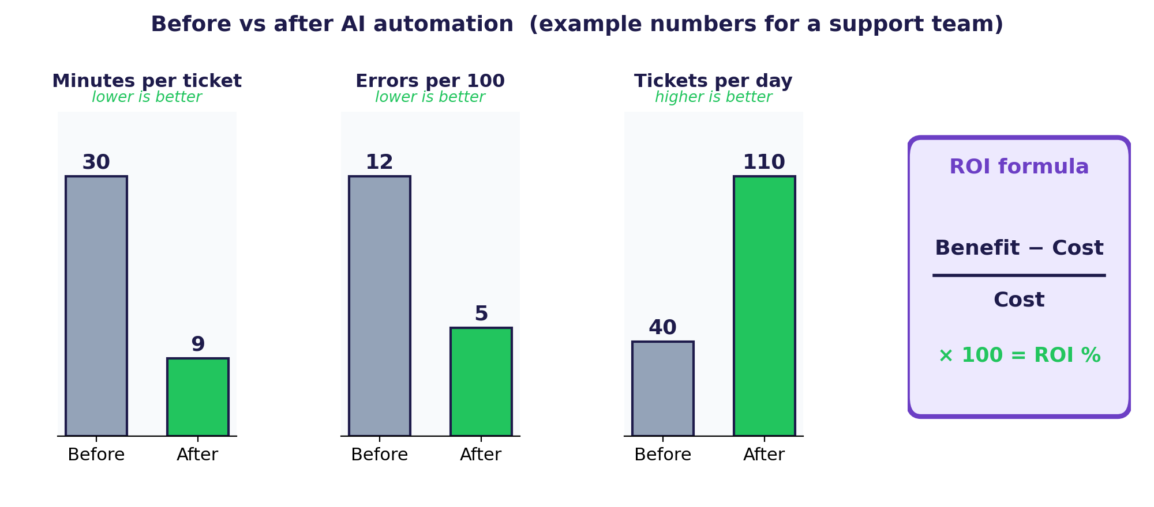
Metric | What it tells you
Time saved | Hours or minutes per task, multiplied by how often it happens
Cost saved | Time saved × hourly value, minus the cost of the tool
Quality | Error rate, rework, customer satisfaction
Throughput | How much work gets done per day

Worked example
A tool costs ₹40,000 and brings ₹1,00,000 of benefit. ROI = (1,00,000 − 40,000) ÷ 40,000 × 100 = 150%.

Tip
Always compare against a baseline: measure the process before AI so you can prove the improvement afterwards.

WORKSHEET 3 | ROI Maths
Name: ____________________ Class: __________ Date: __________ Score: ______
TASK A Solve step by step. Show your working in the space.
A team spends 6 hours a day on data entry. An AI tool cuts that time by 75%. A working day is valued at ₹400 per hour, there are 20 working days in a month, and the tool costs ₹12,000 a month.

Question | Working and answer
1) Hours saved per day
2) Money value saved in 20 days
3) ROI % for the month = (benefit − cost) ÷ cost × 100
4) Errors fell from 10 to 4 per 100 items. What % reduction is that?
TASK B Good measures for a customer-chatbot pilot? Tick Good or Poor.
Measure | Good | Poor
Average reply time | ☐ | ☐
Number of emojis used | ☐ | ☐
Customer satisfaction score | ☐ | ☐
Share of questions solved without a person | ☐ | ☐
TASK C The pilot saves time but customer satisfaction drops. What should you do?

CONCEPT 6 | AI as an Innovation Partner


Innovation is a new idea that is useful and actually gets used. AI helps at every stage, but people still choose the problem, set the taste and take responsibility.
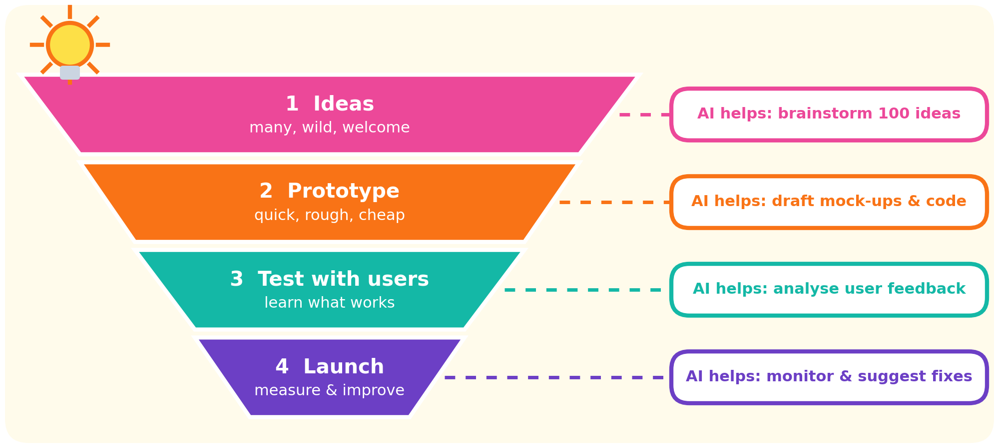
AI is good at… | People are good at… | Together you can…
Producing many options fast, summarising research, drafting prototypes. | Choosing the right problem, empathy, taste, ethics and final decisions. | Explore more ideas, test sooner and avoid costly mistakes.

Innovation = idea + usefulness + adoption
A clever idea nobody uses is not an innovation yet. Test with real users early.

ACTIVITY 3 | Idea Sprint
Name: ____________________ Class: __________ Date: __________ Score: ______
TASK A Turn each problem into a “How might we…?” question. One is done for you.
Problem | How might we…?
Students waste time finding good study resources. | How might we help students find the right resource in under one minute?
New employees feel lost in their first week.
Farmers get weather updates too late.
TASK B Write an R-T-C-F prompt asking an AI for 10 ideas for one of your questions.
TASK C Score three ideas from 1 to 5 on each criterion, then total them.
Idea | Useful | Doable | Responsible | Total
Idea 1
Idea 2
Idea 3

CONCEPT 7 | Design Thinking with AI


Design thinking is a five-stage way to solve problems with users at the centre. AI speeds up each stage, but you must still talk to real people.
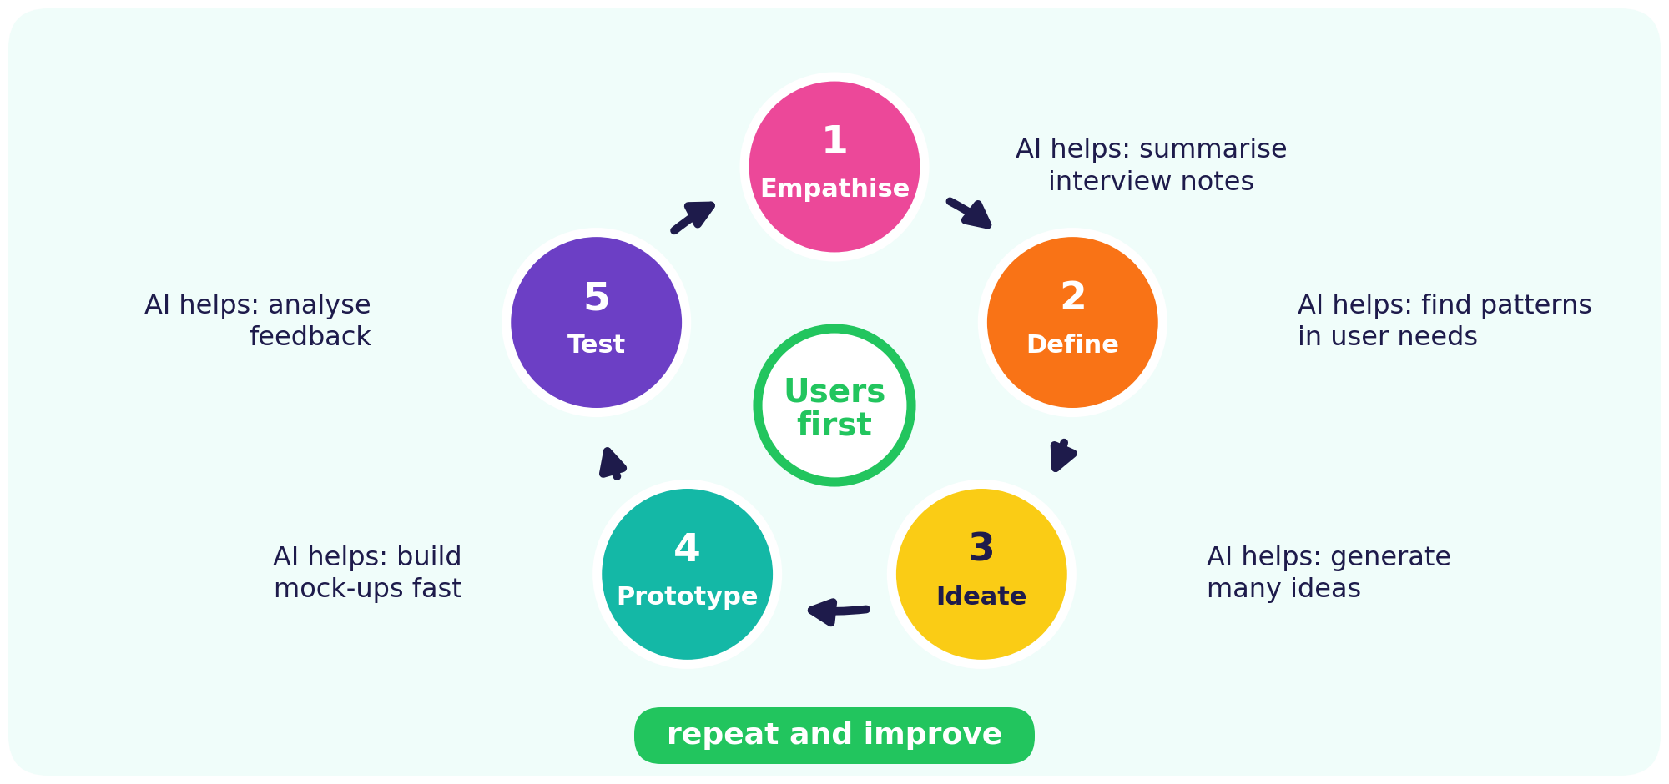
Stage | You | AI can | Remember
1 Empathise | Listen to users | Summarise notes | Meet real people
2 Define | State the problem | Find patterns | You choose
3 Ideate | Explore options | Give many ideas | Pick wisely
4 Prototype | Build a rough version | Draft mock-ups | Check quality
5 Test | Try it with users | Analyse feedback | Decide changes

Fail fast, learn fast
Small, cheap experiments teach more than long plans. Test early, change quickly.

WORKSHEET 4 | Empathy to Prototype
Name: ____________________ Class: __________ Date: __________ Score: ______
TASK A Empathy map for a first-year student who struggles to plan study time. Fill each box.
SAYS | THINKS
DOES | FEELS
TASK B Plan how to test your prototype with users.
What we test | Who tests | Success looks like | Result
Can users add a study task in under 30 seconds? | 5 students | 4 of 5 succeed
TASK C Number the stages from 1 (first) to 5 (last).
Test | Define | Prototype | Empathise | Ideate
No. ____ | No. ____ | No. ____ | No. ____ | No. ____

CONCEPT 8 | AI for Innovation Around the World


Innovators apply AI to real-world problems. In each field the best results come when AI tools work alongside domain experts.
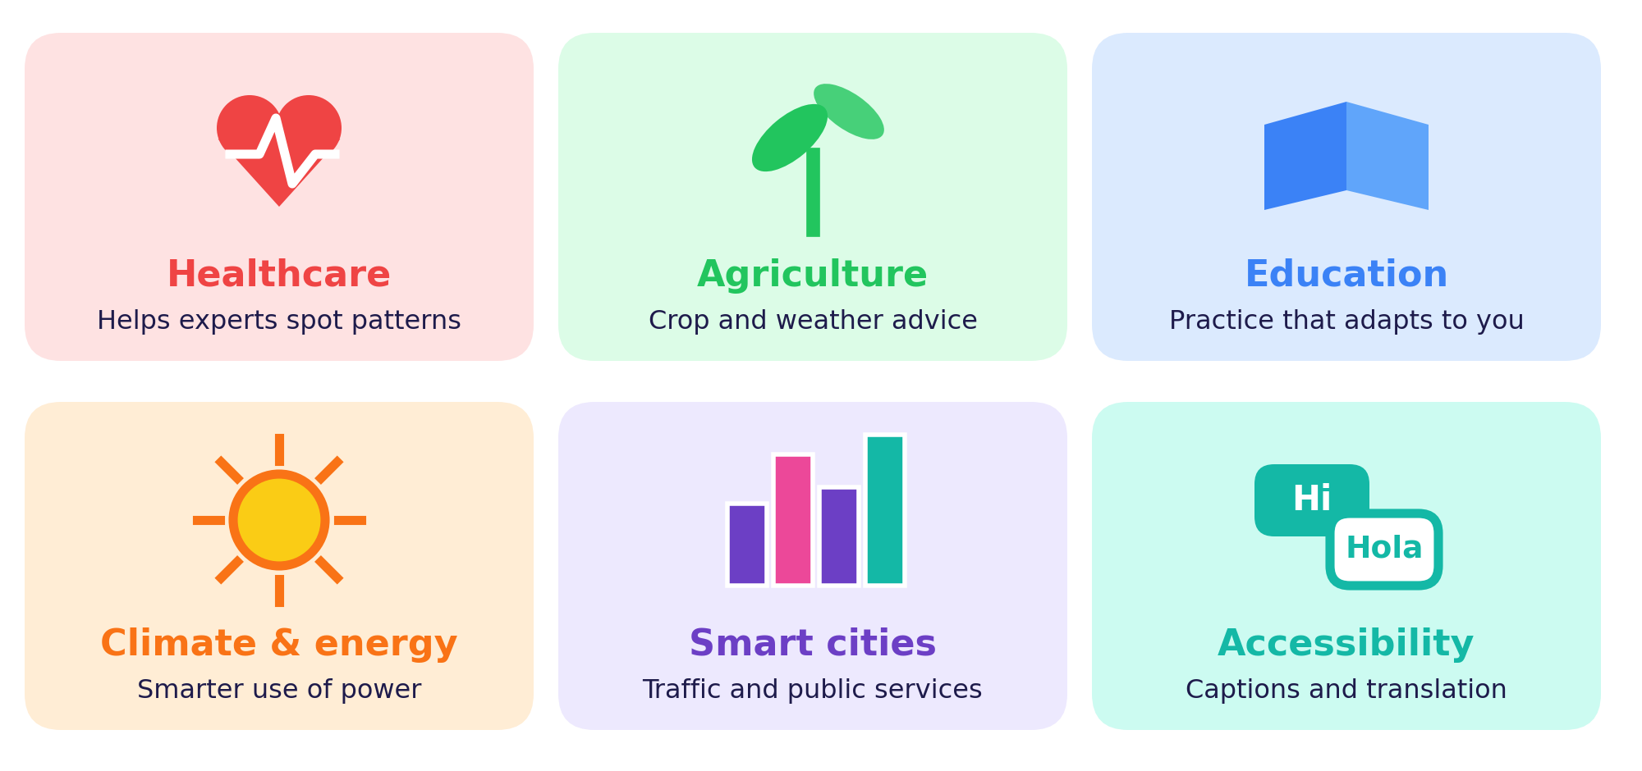
Field | Example idea | Expert needed
Healthcare | Tools that help doctors spot patterns in scans | Doctors
Agriculture | Crop and weather advice for farmers | Farmers, agronomists
Education | Practice questions that adapt to each learner | Teachers
Climate & energy | Smarter use of power in buildings and grids | Engineers
Smart cities | Traffic and public-service planning | City planners
Accessibility | Live captions and translation | Users and designers

Innovation checklist
Is the problem real? Is the data fair? Who could be harmed? How will we measure success?

Rule
Test with real users early. Small experiments beat big guesses.

ACTIVITY 4 | Innovation Pitch Canvas
Name: ____________________ Class: __________ Date: __________ Score: ______
TASK A Plan an AI innovation for a problem you care about. Fill every row.
The problem
Who has it?
Our AI solution
Data we need
What humans still do
Risks and safeguards
How we measure impact
TASK B Write your 30-second pitch: problem, solution, why it is responsible.
TASK C Peer feedback. A classmate rates your pitch.
Clear problem | ☆ ☆ ☆ ☆ ☆
Useful solution | ☆ ☆ ☆ ☆ ☆
Responsible and fair | ☆ ☆ ☆ ☆ ☆

CONCEPT 9 | Responsible Innovation and the Future of Work


AI should make work better for people. Responsible innovators balance AI’s speed and scale with human judgement and care.
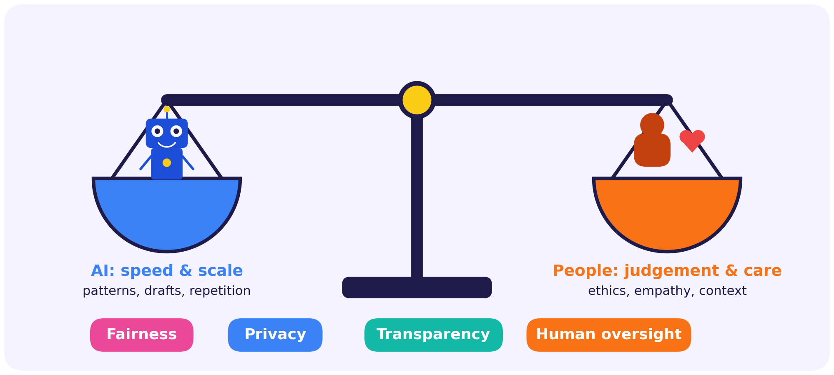
Issue | Example | What to do
Fairness | A hiring tool favours one group | Audit data, test across groups
Privacy | Employee data used without consent | Collect the minimum, ask permission
Transparency | Customers do not know they are talking to a bot | Label AI and explain decisions
Job change | Tasks shift, new skills are needed | Reskill and involve staff early
Accountability | Nobody owns an automated decision | People stay responsible

Future skills
Critical thinking, communication, creativity, data literacy, ethics, and the habit of learning new tools.

Golden rule
An innovation is only good if it is useful, fair and safe for the people it affects.

WORKSHEET 5 | Fact or Fib?
Name: ____________________ Class: __________ Date: __________ Score: ______
TASK A Tick Fact or Fib, then say how you would check it.
# | Statement | Fact | Fib | How to check?
1 | Automation always removes the need for human review. | ☐ | ☐
2 | A quick win has high impact and low effort. | ☐ | ☐
3 | ROI only measures time saved, never money. | ☐ | ☐
4 | Design thinking starts by understanding users. | ☐ | ☐
5 | Biased training data can lead to unfair decisions at work. | ☐ | ☐
6 | An AI pilot should be rolled out to everyone before it is tested. | ☐ | ☐
TASK B Name the principle at risk: Fairness, Privacy, Transparency or Human oversight.
Scenario | Principle
1) A CV-screening tool rejects most applicants from one college
2) A tool reads employees’ private chats without telling them
3) Customers do not know they are chatting with a bot
4) An automated system cancels payments with no way to appeal
TASK C My Innovator Pledge. Write three rules for using AI responsibly at work.
Signature: ______________________

PUZZLE | Work & Innovation Word Search
Name: ____________________ Class: __________ Date: __________ Score: ______
Find all 12 words. They run across, down or diagonally (top-left to bottom-right). Tick each word when you find it.
I | G | X | Q | Z | X | U | Z | J | S | E | K | O | Q | Z
N | W | J | F | W | Y | U | E | Q | O | M | T | Z | A | F
N | F | S | E | O | O | Y | W | N | G | P | G | J | R | O
O | E | X | E | R | L | R | Z | V | X | A | P | U | B | X
V | J | L | D | K | G | J | L | N | A | T | R | U | Y | C
A | R | X | B | F | C | P | Q | B | A | H | O | O | E | Y
T | O | X | A | O | H | R | R | C | U | Y | T | C | H | P
I | I | N | C | R | A | O | S | R | T | E | O | O | B | J
O | N | A | K | C | T | C | J | N | O | R | T | D | H | Z
N | I | H | Z | E | B | E | A | N | M | P | Y | E | F | A
S | R | K | M | V | O | S | V | N | A | O | P | O | Y | V
V | E | L | Q | Q | T | S | Q | D | T | C | E | G | Y | Q
X | S | M | J | G | K | O | C | E | I | S | C | A | L | E
G | M | E | R | O | Y | U | T | E | O | P | I | L | O | T
A | U | G | M | E | N | T | E | M | N | F | D | K | L | I

☐ AUTOMATION | ☐ INNOVATION | ☐ PROTOTYPE | ☐ WORKFORCE
☐ FEEDBACK | ☐ EMPATHY | ☐ CHATBOT | ☐ AUGMENT
☐ PROCESS | ☐ SCALE | ☐ PILOT | ☐ ROI

Riddles. Write the answer.
a) I compare the benefit of a project with its cost. ____________
b) I am a small test run before a big launch. ____________
c) I mean seeing a problem through the user’s eyes. ____________

QUIZ | Olympiad Challenge Quiz
Name: ____________________ Class: __________ Date: __________ Score: ______
Part A – Circle the best answer (1 mark each)
1. Which task is most suitable for full automation?
(A) Negotiating a contract (B) Sorting invoices by type (C) Comforting an upset customer (D) Setting company ethics
2. “Augmentation” means…
(A) Humans replace AI (B) Nothing changes (C) AI and people work together (D) AI replaces all staff
3. A “quick win” has…
(A) low impact and high effort (B) high effort and high impact (C) low impact and low effort (D) high impact and low effort
4. ROI is calculated as…
(A) (Benefit − Cost) ÷ Cost × 100 (B) Cost ÷ Benefit (C) Benefit + Cost (D) Time × Cost
5. What comes first in design thinking?
(A) Build the product (B) Empathise with users (C) Write the code (D) Launch widely
6. Why keep a human review step in an automated process?
(A) To make it slower (B) To hide the AI (C) To catch costly or unfair mistakes (D) Because AI cannot read text
7. A pilot is…
(A) a company-wide launch (B) a small test run (C) a type of robot (D) a budget report
8. Biased training data can cause…
(A) faster internet (B) smaller files (C) fairer results always (D) unfair decisions
9. A good measure for a chatbot pilot is…
(A) customer satisfaction (B) colour of the chat window (C) number of emojis (D) font size
10. As AI spreads, which skill matters most?
(A) Avoiding teamwork (B) Ignoring data (C) Critical thinking and ethics (D) Never learning new tools
Part B – Short answers (3 marks each)
11. Give one task to automate, one to augment and one to keep human-led.
12. List two metrics for a pilot of an AI helpdesk assistant.

Total score: ______ / 16 Grade / Stars: ☆ ☆ ☆ ☆ ☆

ANSWERS | Answer Key

p4 Worksheet 1 | A: 1 Automate, 2 Augment, 3 Human, 4 Automate, 5 Augment, 6 Human, 7 Automate, 8 Augment, 9 Human, 10 Automate. B, C: answers will vary.
p6 Activity 1 | A: sorting email = Quick win; monthly report = Fill-in; chatbot = Big bet; rebuild whole system = Avoid for now. B, C: answers will vary; look for clear reasons.
p8 Worksheet 2 | A: 1 C, 2 E, 3 A, 4 B, 5 D, 6 F. B: the bot may start with an apology and tracking help, but should hand over to a person for an upset customer or a refund dispute. C: Appropriate, Appropriate, Not OK, Not OK.
p10 Activity 2 | Processes will vary. Look for routine steps given to AI (sorting, drafting), a human review of decisions, and a flowchart that marks the review step.
p12 Worksheet 3 | 1: 6 × 75% = 4.5 hours. 2: 4.5 × 20 × 400 = ₹36,000. 3: (36,000 − 12,000) ÷ 12,000 × 100 = 200%. 4: (10 − 4) ÷ 10 = 60% fewer errors. B: Good, Poor, Good, Good. C: investigate why, add human help, adjust before scaling.
p14 Activity 3 | Answers will vary. A (sample): How might we help new employees find answers on day one? How might we send farmers timely weather alerts? B: check for role, task, context and format.
p16 Worksheet 4 | A, B: answers will vary. C: Test 5, Define 2, Prototype 4, Empathise 1, Ideate 3.
p18 Activity 4 | Pitches will vary. Check that the problem, data, human role, risks and a way to measure impact are all covered.
p20 Worksheet 5 | A: 1 Fib, 2 Fact, 3 Fib, 4 Fact, 5 Fact, 6 Fib. B: 1 Fairness, 2 Privacy, 3 Transparency, 4 Human oversight.
p21 Puzzle | Riddles: a) ROI, b) pilot, c) empathy. Positions: AUTOMATION (r6, c10, down); INNOVATION (r1, c1, down); PROTOTYPE (r4, c12, down); WORKFORCE (r2, c5, down); FEEDBACK (r2, c4, down); EMPATHY (r1, c11, down); CHATBOT (r6, c6, down); AUGMENT (r15, c1, across); PROCESS (r6, c7, down); SCALE (r13, c11, across); PILOT (r14, c11, across); ROI (r6, c2, down).
p22 Quiz | Part A: 1 B, 2 C, 3 D, 4 A, 5 B, 6 C, 7 B, 8 D, 9 A, 10 C. Part B: 11 e.g. sort emails / draft reports / deliver bad news. 12 e.g. reply time, satisfaction, share solved without a person.

Teacher note
Open-ended tasks (audits, redesigns, pitches) reward clear reasoning rather than one correct answer. Encourage students to compare answers in pairs.

